Science 10 Velocity time graph review assignment - Online Learning Assignment Jan 21, 2022
NAME:________________________________

- Watch the video: Velocity Time Graphs Part 4 Area Kinematics Physics Tutorial - YouTube and answer the following questions.
- Complete the graph below as he does on the video going over to 9 seconds. Also show the calculation for getting the displacement = -8 m West and the distance = 28 m total from finding the areas.
V

- t (s)

- Go to the web site:
Physics Simulation: Graph That Motion (physicsclassroom.com) and go through the 11 animations of motion types.
Then Draw and label the little graph (sketch) below for each of the first 10 animations: ( I have done #1 for you )
Animation 1 Animation 6
Const Speed East, Stopped, Const Speed West
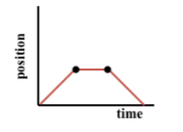
Animation 2 Animation 7

Animation 3 Animation 8

Animation 4 Animation 9

Animation 5 Animation 10

